Author: Atta Kwami

KOFI , Vincent Akwete (1923-74) was born in Odumasi-Krobo, Ghana. After training at Achimota College, which had the first and foremost art department in West Africa, he continued his studies at the Royal College of Art, London (1952-55), and Columbia University, New York (1959). While in New York, he learned metal casting and, with the assistance of the Harmon Foundation, produced a film on bronze casting. He taught at the Winneba Teacher Training College (1961-69) and was Head of Fine Art, College of Art, (KNUST), Kumasi, (1969-74). He was a member of the Ghanaian delegation at the First World Festival of Negro Arts, Dakar, 1966. In 1971 he visited India at the invitation of the Government. His early influences were his Krobo environment, his artistic father, the Presbyterian minister James Kofi (1890-1976), who made drawings and teaching aids for Nature Study classes. In his middle period he drew inspiration from his days at Achimota College (c. 1945-51), where the pervasive atmosphere of optimism and hope for a new Africa fired Ghanaian nationalism and the independence struggle. Kofi believed that he could fuse lessons from the history of modernism in the arts, ‘creatively and objectively’, only by an immersion in his Ghanaian heritage. His sculptures, Awakening Africa (1959-60) and Blackman’s Stoicism (1964), highlighted Pan-Africanism, and the decolonisation process that was spreading across Africa.

In his late works he explored bold figural concepts such as the lens-shaped akua’ba head and ringed neck of Akan sculptural traditions and notions of spirituality. His Okyeremang of 1964 belongs to a trilogy of figures: the dancer, the hornblower and the drummer that Kofi referred to as the “holy trilogy”. That Kofi left The Hornblower outside Nkrumah's rest house, Peduase Lodge, to be eaten by ants after the coup d'etat in Ghana in 1966, shows his awareness that a sculpture is made for a particular time and a particular place, and not for a connoisseur's collection or a museum vault...’.

Kofi gained wide international recognition through creating what he called “world art”. Rhoda Woets notes that Kofi achieved a ‘calibre of “world art” [...] by understanding and artistically interpreting local “traditional” customs. Kofi died aged 51. James Kwegir Aggrey’s and Kwame Nkrumah’s Pan-Africanist ideals motivated Kofi to formulate a distinctive Ghanaian approach, based on an understanding of Ghanaian art, to re-define a modern African identity.

References and Further reading

Amegatcher, Gilbert. 1992. ‘Vincent Kofi, 1923-1974: A Critical Biography of an African Artist’, 16. Masters thesis, Indiana University, [unpublished].

Grobel, Lawrence. 1975. ‘Vincent Kofi’. In African Arts, 8: 3, Los Angeles.

Kofi, Vincent. 1964. Sculpture in Ghana, Ghana Information Services, Accra.
Woets, Rhoda. 2011. ‘“What is This!?” Framing Ghanaian art from the Colonial Encounter to the Present.’, 146. Unpublished Ph.D. thesis, VU University Amsterdam.

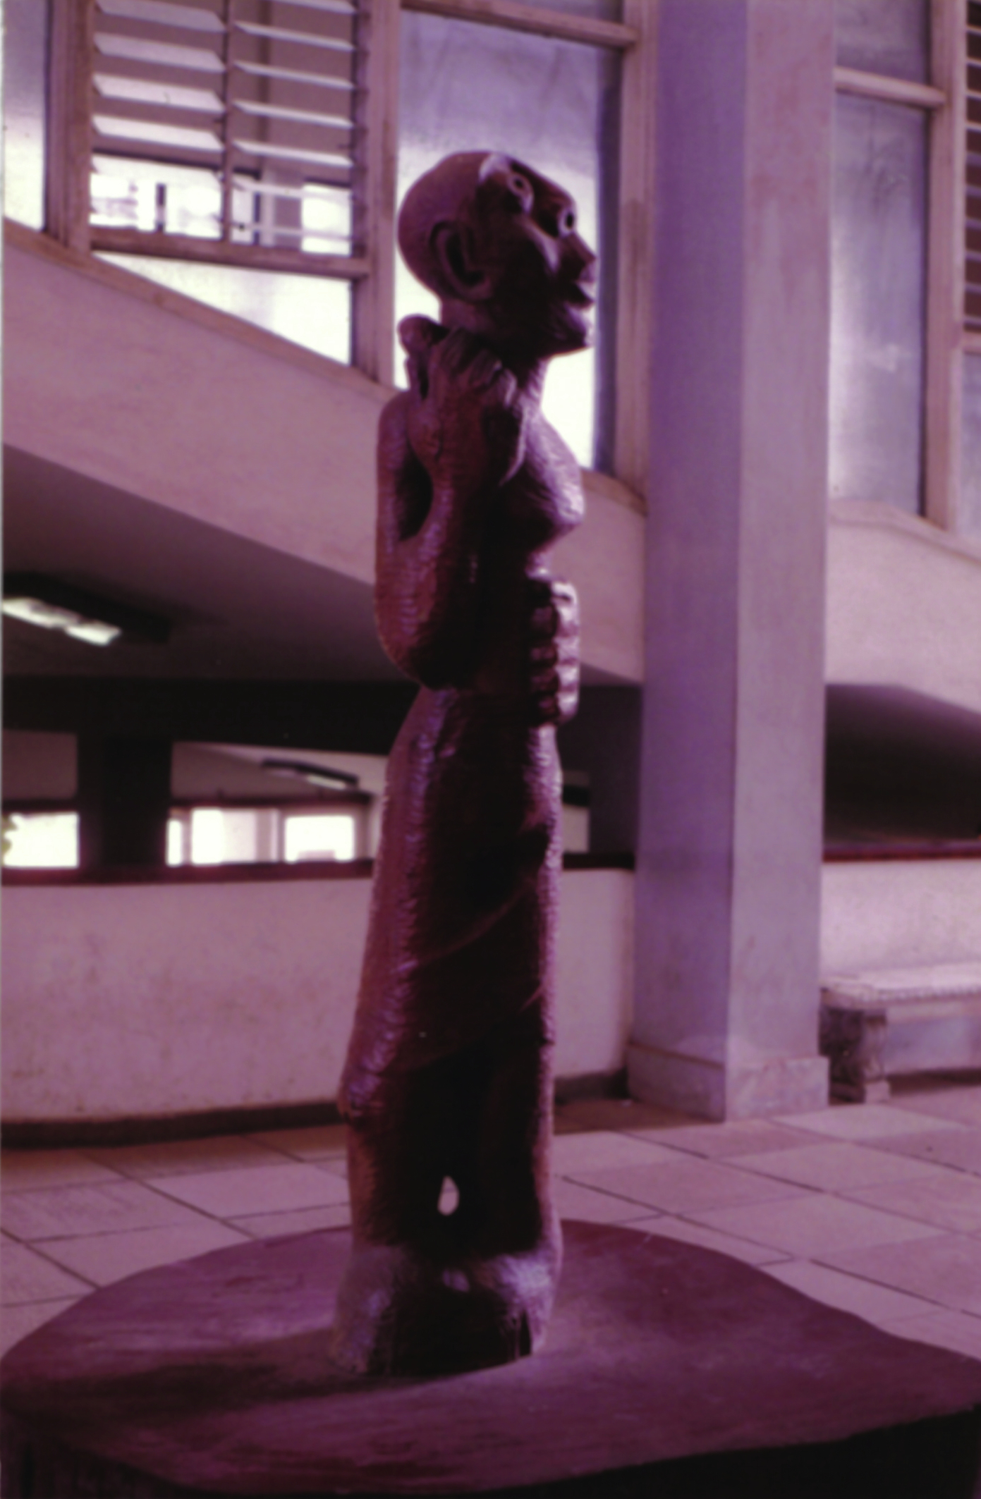
Illustration:
Vincent Akwete Kofi, Okyremang, (Chief drummer) 1964.

Manzonia wood

University of Ghana, Legon
Photographed by Atta Kwami 1990.

